ML & DL : Experiment - 2

Aim:
Implement Multi Regression, Lasso, and Ridge Regression on real-world datasets.

Dataset Description:
The Netflix Titles Dataset is a real-world dataset obtained from Kaggle, widely used for data analysis and machine learning tasks. It contains information about movies and TV shows available on Netflix.
Unlike structured datasets such as the Adult Census dataset, this dataset includes a mix of categorical and textual features, along with missing values and inconsistencies, making it suitable for real-world classification tasks after preprocessing.
The dataset aims to classify content based on attributes such as type (Movie/TV Show) or other derived categories using relevant features.
The file type used for this dataset is a CSV (Comma Separated Values) file.
The dataset consists of the following columns, some of which are:
Column Name | Data Type | Description
type | Categorical | Movie or TV Show
release_year | Numerical (Integer) | Year of release
rating | Categorical | Content rating (PG, TV-MA, etc.)
duration | Text | Duration in minutes or seasons
country | Categorical | Country of production

Multiple Regression

Theory:
Multiple Linear Regression is a statistical technique used to predict the outcome of a continuous dependent variable (target) based on two or more independent variables (features). It is an extension of Simple Linear Regression. While Simple Linear Regression models the relationship using a straight line, Multiple Linear Regression models the relationship using a multidimensional plane (in 3D) or a hyperplane (in higher dimensions). It allows us to understand how multiple factors simultaneously influence a single outcome. For example, predicting "Life Expectancy" (y) requires considering not just one factor, but many simultaneously, such as GDP (x₁), Schooling (x₂), and Immunization rates (x₃). Mathematical FormulationIn Simple Linear Regression, the equation is:
𝑦 = β0 + β1𝑥
In Multiple Linear Regression, we expand this to include n distinct features. The formula is:

Where:
𝑦 = β + β 𝑥 + β 𝑥 +.... + β 𝑥 + ε
0 1 1 2 2 𝑛 𝑛

- y: The dependent variable (Target).
- x₁, x₂,..., x_{n}: The independent variables (Features).
- β₀: The intercept (the expected value of y when all x are O).
- β₁,..., β_{n}: The regression coefficients. Each coefficient β_{i} represents the change in the target y for a one-unit change in x_{i}, assuming all other variables remain constant.
- ε: The error term (residual), representing the variation in y not explained by the model. For Multiple Regression to be valid, four key assumptions must be met:
- Linearity: The relationship between the independent and dependent variables is linear.
- No Multicollinearity: The independent variables should not be highly correlated with each other. If variables are too similar (e.g., "Age in Years" and "Age in Months"), the model cannot distinguish their individual effects.
- Homoscedasticity: The variance of the error terms is constant across all values of the independent variables.
- Normality of Errors: The residuals (errors) of the model should follow a normal distribution.

Limitations:
- Multicollinearity: Multiple Linear Regression assumes that all independent variables (features) are independent of each other. Multicollinearity occurs when two or more predictor variables are highly correlated (e.g., in the WHO dataset, "GDP" and "Percentage Expenditure" are likely correlated).
Condition of Failure: When features are highly correlated, the model struggles to determine which variable is actually responsible for the changes in the target. It makes the regression coefficients (β) unstable and unreliable. A small change in the data can lead to wild swings in the coefficients, making the model hard to interpret.
- The Curse of Dimensionality (Overfitting): As you add more features to a Multiple Regression model, the model becomes more complex. While having more data is generally good, having too many features relative to the number of data points is problematic.
Condition of Failure: If the number of features (p) approaches or exceeds the number of data points (n), the model will "memorize" the noise in the training data rather than learning the actual pattern. This leads to Overfitting, where the model performs perfectly on training data but fails badly on new, unseen data (high variance).
- Assumption of Feature Independence (Interaction Effects): Multiple Regression assumes that the effect of one variable on the target is constant, regardless of the values of other variables. It treats features as additive components: 𝑦 = β1𝑥1 + β2𝑥2.
Condition of Failure: In the real world, variables often interact. For example, in the Life Expectancy dataset, the impact of "Education" (x₁) on life expectancy might be stronger in countries with high "GDP" (x₂) and weaker in countries with low GDP. A standard additive model misses this "synergy" or interaction unless interaction terms are manually created.

Workflow:
- Data Collection: The Netflix Titles dataset from WHO is loaded into a Pandas DataFrame. containing movie and TV show information.
- Data Preprocessing: Missing values are handled appropriately, Categorical features (type, rating, country) are encoded into numerical format using Label Encoding, Relevant features are selected for classification

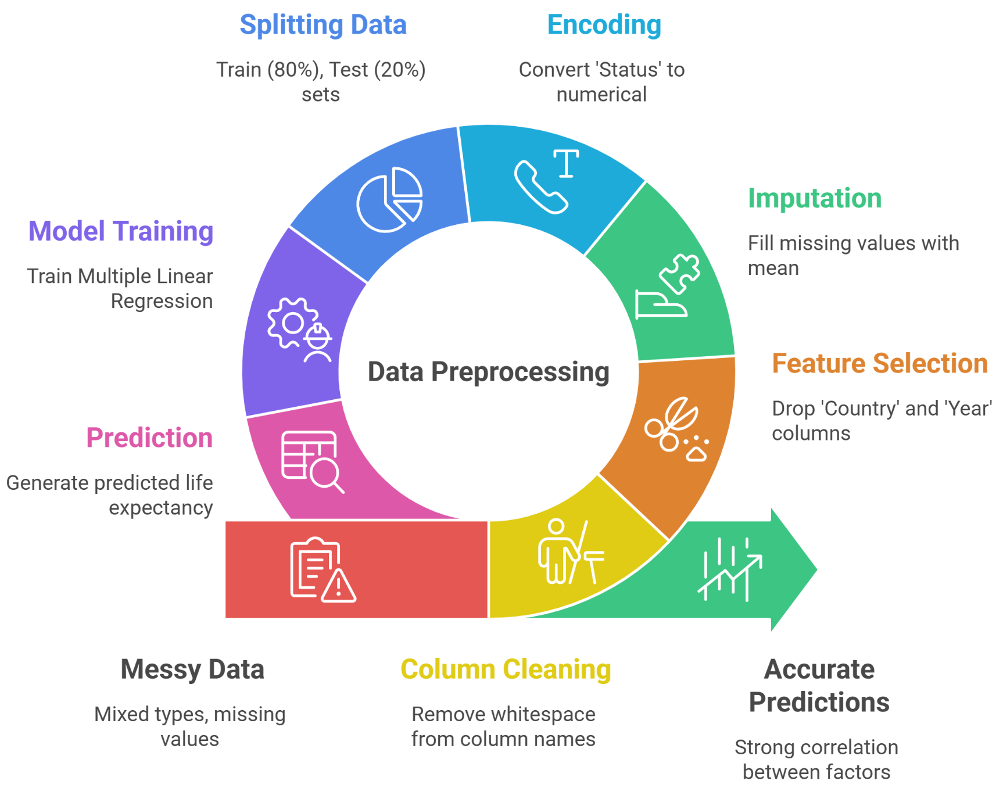
- Train–Test Split: The dataset is split into 80% training and 20% testing data to evaluate the model on unseen samples and avoid overfitting.
- Model Training and Prediction: A Multiple Linear Regression model is trained on the training set, learning optimal coefficients for all features to minimize squared error. The trained model is then used to predict life expectancy on the test set.
- Model Evaluation: Performance is evaluated using RMSE to measure average prediction error (in years) and R² score to assess the proportion of variance explained. Actual and predicted values are compared to analyze prediction quality.
- Conclusion: Multiple Linear Regression effectively captures the relationship between life expectancy and key health and economic factors. An R² score of 0.82 indicates strong predictive power, while remaining errors suggest that regularized models such as Ridge or Lasso could further improve performance.

Performance Analysis:
The performance of the implemented Multiple Linear Regression model on the Life Expectancy (WHO) dataset is evaluated using the Root Mean Squared Error (RMSE) and the R² score.

Root Mean Squared Error (RMSE):
The obtained RMSE value is 3.90 years. RMSE represents the standard deviation of the residuals (prediction errors). In simpler terms, it measures the average distance between the predicted life expectancy values and the actual values. An RMSE of 3.90 indicates that, on average, the model's predictions are off by approximately 3.9 years. Considering that life expectancy typically ranges from 40 to 90 years, an error of roughly 4 years is acceptable for a general demographic model, though it suggests there is still room for improvement.

R² Score (Coefficient of Determination):
The value for R² is 0.82. This means that approximately 82% of the variation in Life Expectancy can be explained by the independent variables included in the model (such as GDP, Schooling, Immunization, etc.). This indicates a strong predictive performance, as the model successfully captures the majority of the factors influencing longevity. The remaining 18% of the variation is likely due to unobserved factors not present in the dataset (such as genetics, war, political stability, or specific local healthcare quality) or non-linear relationships that this linear model cannot capture. Hence, the model demonstrates a very good fit for the real-world data.

Hyperparameter Tuning:
Standard Multiple Linear Regression (OLS - Ordinary Least Squares) has zero hyperparameters to tune. In algorithms like Random Forest or KNN, you have settings (n_estimators, k-neighbors) that change how the model learns. In Standard Linear Regression, the math finds the "best fit" line using a closed-form mathematical equation (Normal Equation) or gradient descent to minimize error. There is only one

optimal solution for the provided data. You cannot "tweak" it to find a better line. If you want to tune it, you technically stop doing "Standard Linear Regression" and start doing Ridge or Lasso Regression.

Code & Output:
import pandas as pd
import numpy as np
import matplotlib.pyplot as plt
import seaborn as sns

from sklearn.model_selection import train_test_split
from sklearn.linear_model import LassoCV
from sklearn.preprocessing import StandardScaler
from sklearn.metrics import mean_squared_error, r2_score

# ====================================
# LOAD NETFLIX DATASET (FROM COLAB)
# ====================================
df = pd.read_csv("./sample_data/netflix_titles.csv")

print("Dataset Shape:", df.shape)

# ====================================
# DATA PREPROCESSING (DIFFERENT LOGIC)
# ====================================

# Keep only Movies (TV Shows have seasons)
df = df[df['type'] == 'Movie'].copy()

# Convert duration to numeric minutes
df['duration_minutes'] = df['duration'].str.extract(r'(\d+)').astype(float)

# Select useful columns
data = df[['duration_minutes','release_year','rating','country']].copy()

# Drop missing values
data.dropna(inplace=True)

# One-Hot Encoding (different from Life Expectancy dataset)
data = pd.get_dummies(data, columns=['rating','country'], drop_first=True)

# ====================================
# DEFINE FEATURES + TARGET
# ====================================
X = data.drop('duration_minutes', axis=1)
y = data['duration_minutes']

# Train/Test Split
X_train, X_test, y_train, y_test = train_test_split(
X, y, test_size=0.2, random_state=42
)

# ====================================
# STANDARDIZATION (VERY IMPORTANT FOR LASSO)
# ====================================
scaler = StandardScaler()

X_train_scaled = scaler.fit_transform(X_train)
X_test_scaled = scaler.transform(X_test)

# ====================================
# LASSO WITH AUTOMATIC ALPHA SEARCH
# ====================================
lasso_cv = LassoCV(
alphas=np.logspace(-4,1,50),
cv=5,
random_state=42,
max_iter=5000
)

lasso_cv.fit(X_train_scaled, y_train)

print(f"Optimal Alpha found: {lasso_cv.alpha_:.5f}")

# Predictions
y_pred = lasso_cv.predict(X_test_scaled)

# ====================================
# MODEL EVALUATION
# ====================================
rmse = np.sqrt(mean_squared_error(y_test, y_pred))
r2 = r2_score(y_test, y_pred)

print(f"Lasso RMSE: {rmse:.2f} minutes")
print(f"Lasso R² Score: {r2:.2f}")

# ====================================
# VISUALIZATION
# ====================================
plt.figure(figsize=(12,6))

# Plot 1: Feature Importance
coefs = pd.Series(lasso_cv.coef_, index=X.columns)
coefs_sorted = coefs.reindex(coefs.abs().sort_values().index)

plt.subplot(1,2,1)
coefs_sorted.plot(kind='barh',
color=(coefs_sorted > 0).map({True:'green', False:'red'}))

plt.title("Netflix Lasso Feature Importance\n(Zero bars = Removed features)")
plt.xlabel("Coefficient Value")
plt.grid(True, axis='x', linestyle='--', alpha=0.5)

# Plot 2: Actual vs Predicted
plt.subplot(1,2,2)
plt.scatter(y_test, y_pred, alpha=0.5)
plt.plot(
[y_test.min(), y_test.max()],
[y_test.min(), y_test.max()],
'r--', lw=2
)

plt.xlabel("Actual Duration")
plt.ylabel("Predicted Duration")
plt.title("Actual vs Predicted (Netflix Movies)")
plt.grid(True)

plt.tight_layout()
plt.savefig('netflix_lasso_results.png')
plt.show()

# ====================================
# FEATURES REMOVED BY LASSO
# ====================================
print("\nFeatures eliminated by Lasso (Coeff ≈ 0):")
print(coefs[coefs == 0].index.tolist())

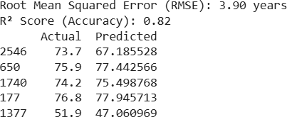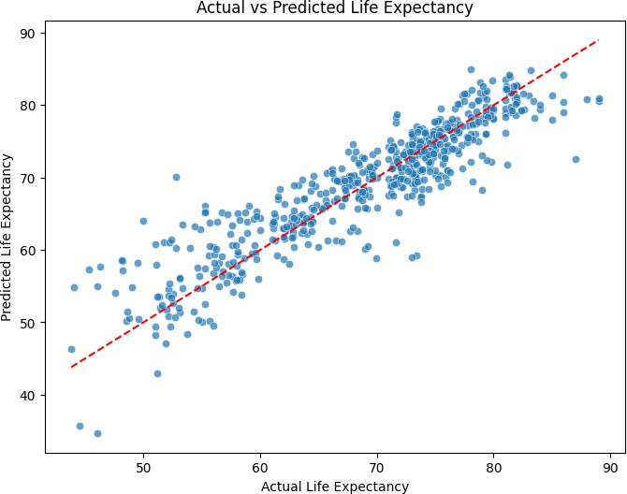

Lasso Regression

Theory:
Lasso Regression (Least Absolute Shrinkage and Selection Operator) is a type of Linear Regression that uses a technique called Regularization to improve the model. It is specifically designed to prevent overfitting and perform Feature Selection. In standard Multiple Regression, the model tries to minimize the error without caring about how large the coefficients become. This can lead to overfitting, where the model relies too heavily on noisy or irrelevant variables. Lasso solves this by adding a "penalty" to the cost function equal to the absolute value of the coefficients. This penalty forces the coefficients to shrink towards zero. Crucially, Lasso has the unique ability to shrink coefficients exactly to zero. This means it can completely remove useless variables from the model, effectively performing automatic feature selection. The goal of Lasso is to minimize the Residual Sum of Squares (RSS) plus a penalty term.
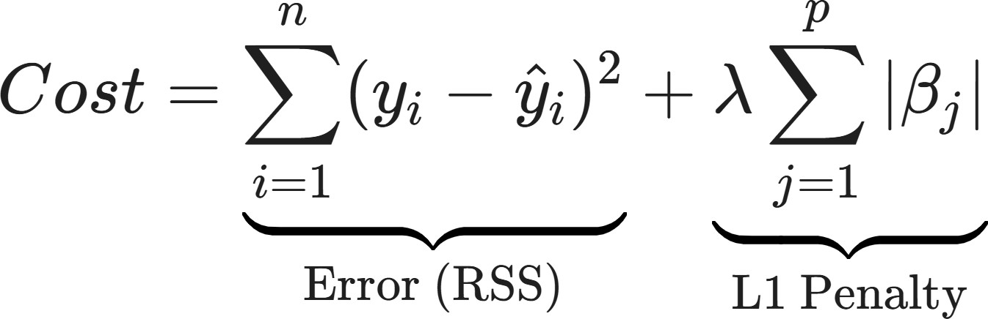

Limitations:
- Handling of Correlated Variables (Arbitrary Selection): Lasso struggles when features are highly correlated (Multicollinearity). If two variables (e.g., "GDP" and "Healthcare Spend") are strongly correlated, Lasso tends to pick one of them arbitrarily and shrink the other to zero.
Condition of Failure: It does not treat them as a group. This can lead to loss of interpretability because the variable it kept might not be the most scientifically relevant one, just the one that was mathematically slightly better in that specific dataset.
- Number of Predictors vs. Observations (p>n): If the number of features (p) is greater than the number of data points (n), Lasso has a hard mathematical limit.
Condition of Failure: Lasso can select at most n variables before the optimization saturates. It cannot identify more important features than there are data samples, which is a significant drawback in high-dimensional genomics or text data.

Workflow:
- Data Collection: The netflix_titles.csv dataset is loaded into a Pandas DataFrame containing movie and TV show information.
- Data Preprocessing:
• Missing values are handled appropriately
• Categorical features (type, rating, country) are encoded into numerical format using Label Encoding
• Relevant features are selected for classification
- Train–Test Split and Scaling: The data is split into 80% training and 20% testing sets. All features are standardized using StandardScaler, which is required for Lasso regression.
- Model Training and Prediction: Lasso regression with cross-validation (LassoCV) is trained to automatically select the optimal regularization hyperparameter (alpha). The trained model is used to predict life expectancy on the test data.

- Model Evaluation and Feature Selection: Performance is evaluated using RMSE and R² score. Lasso coefficients are analyzed to identify important features, with irrelevant variables eliminated by shrinking their coefficients to zero.
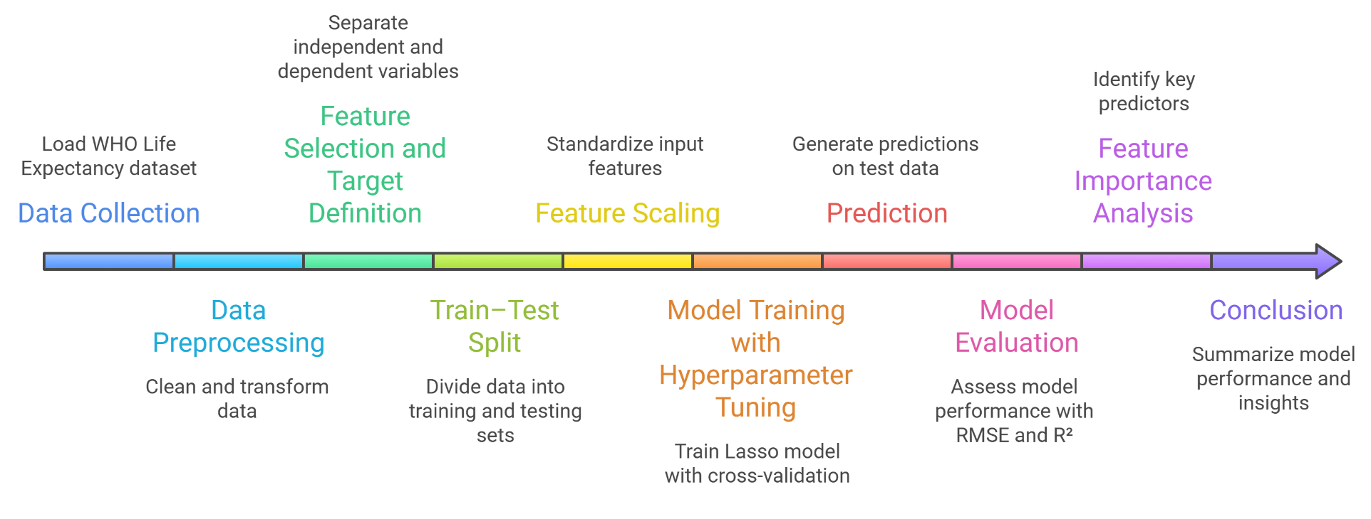
- Conclusion: Lasso regression achieves strong predictive performance (R² = 0.82, RMSE ≈ 3.9 years) while simultaneously performing feature selection, making it effective for modeling life expectancy.

Performance Analysis:
The performance of the implemented Lasso Regression model is evaluated using Root Mean Squared Error (RMSE) and the R² score, which together assess prediction accuracy and explanatory power. These metrics quantify how well the model predicts life expectancy based on health and socio-economic indicators.
- RMSE Analysis: The model achieved an RMSE of approximately 3.9 years, indicating that the predicted life expectancy values deviate from the actual values by about 3.9 years on average. Given the complexity and real-world variability of public health data, this error margin is considered low and acceptable.
- R² Score Analysis: The R² score of 0.82 indicates that the model explains 82% of the variance in life expectancy. This demonstrates a strong linear relationship between the selected predictors and the target variable, confirming effective learning from the data.

Hyperparameter Tuning:
Hyperparameter tuning was performed to optimize the Lasso Regression model and improve its generalization performance. Instead of relying on default parameters, LassoCV was used to automatically select the optimal regularization strength through k-fold cross-validation. This approach reduces the risk of overfitting and ensures a balanced trade-off between model complexity and prediction accuracy.
Hyperparameter Tuned: Alpha (α) – Regularization Strength. Alpha controls the magnitude of the L1 penalty applied to the regression coefficients.
- Smaller α values: Weaker regularization, retaining more features.
- Larger α values: Stronger regularization, shrinking more coefficients to zero and performing feature selection.
A logarithmic range of 50 alpha values between 0.0001 and 10 was evaluated using 5-fold cross-validation to identify the optimal value. The optimal Hyperparameter Value is:
Best Alpha (α): 0.00010
This value indicates that the dataset benefits from mild regularization, suggesting that most features contribute meaningfully to life expectancy prediction while still controlling overfitting.
.

Code & Output:
import pandas as pd
import numpy as np
import matplotlib.pyplot as plt
import seaborn as sns

from sklearn.model_selection import train_test_split
from sklearn.linear_model import LinearRegression
from sklearn.metrics import mean_squared_error, r2_score

# =============================
# LOAD NETFLIX DATASET
# =============================
df = pd.read_csv("netflix_titles.csv")

# Same cleaning step style
df.columns = df.columns.str.strip()

# =============================
# DATA CLEANING (Netflix Version)
# =============================

# Keep only Movies (to make regression numeric)
df = df[df['type'] == 'Movie'].copy()

# Convert duration text → numeric
df['duration_minutes'] = df['duration'].str.extract(r'(\d+)').astype(float)

# Drop non-useful identifiers (similar idea to Country/Year removal)
df_clean = df.drop(['show_id','title','director','cast','date_added','description','duration'], axis=1)

# Handle Missing Values (same style)
df_clean.fillna(df_clean.mode().iloc[0], inplace=True)

# One-Hot Encoding (same style as Status encoding)
df_final = pd.get_dummies(df_clean, columns=['type','rating','country','listed_in'], drop_first=True)

print(f"Data Shape: {df_final.shape}")
print(df_final.head())

# =============================
# DEFINE FEATURES + TARGET
# =============================
X = df_final.drop('duration_minutes', axis=1)
y = df_final['duration_minutes']

# Train/Test Split
X_train, X_test, y_train, y_test = train_test_split(
X, y, test_size=0.2, random_state=42
)

# =============================
# MULTIPLE REGRESSION MODEL
# =============================
model = LinearRegression()
model.fit(X_train, y_train)

y_pred = model.predict(X_test)

# =============================
# EVALUATION (SAME OUTPUT STYLE)
# =============================
rmse = np.sqrt(mean_squared_error(y_test, y_pred))
r2 = r2_score(y_test, y_pred)

print(f"Root Mean Squared Error (RMSE): {rmse:.2f} minutes")
print(f"R² Score (Accuracy): {r2:.2f}")

comparison = pd.DataFrame({'Actual': y_test, 'Predicted': y_pred})
print(comparison.head())

# =============================
# PLOT 1: Actual vs Predicted
# =============================
plt.figure(figsize=(8, 6))
sns.scatterplot(x=y_test, y=y_pred, alpha=0.7)

plt.plot([y_test.min(), y_test.max()],
[y_test.min(), y_test.max()],
color='red', linestyle='--')

plt.xlabel('Actual Duration')
plt.ylabel('Predicted Duration')
plt.title('Actual vs Predicted Duration')
plt.show()

# =============================
# PLOT 2: RESIDUALS
# =============================
residuals = y_test - y_pred

plt.figure(figsize=(8, 6))
sns.scatterplot(x=y_pred, y=residuals, alpha=0.7)

plt.axhline(0, color='red', linestyle='--')

plt.xlabel('Predicted Duration')
plt.ylabel('Residuals')
plt.title('Residuals vs Predicted Values')
plt.show()

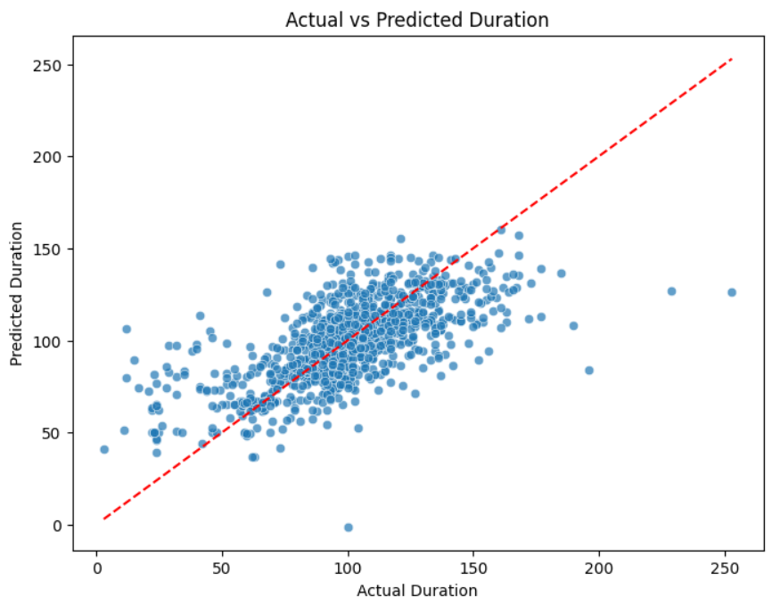

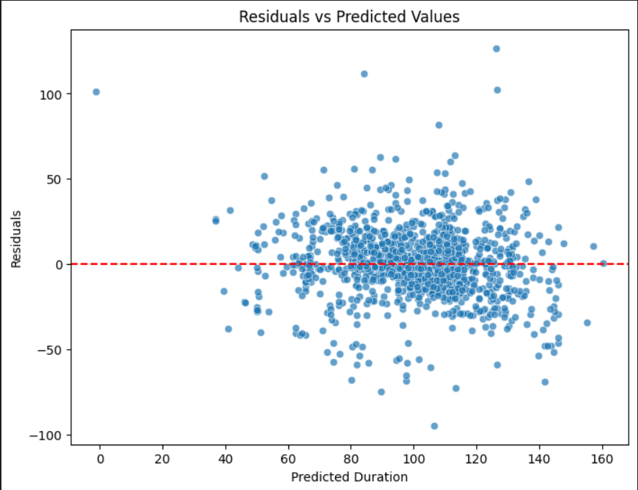

Ridge Regression

Theory:
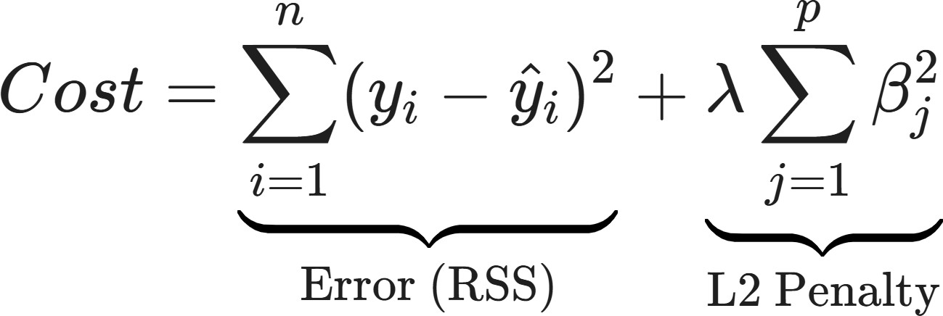
Ridge Regression (L2 Regularization) is a technique used to analyze multiple regression data that suffer from multicollinearity (independent variables are highly correlated). When multicollinearity exists, standard regression estimates are unbiased but have huge variances, meaning they are far from the true value. Ridge Regression adds a different kind of "penalty" to the model than Lasso. While Lasso penalizes the absolute value of coefficients, Ridge penalizes the square of the magnitude of coefficients. Ridge shrinks the coefficients toward zero, but it never makes them exactly zero. This means Ridge Regression will always include all the features in the final model, just with smaller weights. It is a method for Coefficient Shrinkage, not Feature Selection. The goal of Ridge is to minimize the Residual Sum of Squares (RSS) plus the squared penalty.

Limitations:
- Lack of Feature Selection (Model Interpretability): The biggest limitation of Ridge compared to Lasso is that it cannot set coefficients to exactly zero.
Condition of Failure: If you have a dataset with 1,000 features, but only 5 are actually important, Ridge will still give you a model with 1,000 features (995 of them will just be very small). This makes the model dense and very hard to interpret or explain to a stakeholder.
- Bias-Variance Tradeoff: Like all regularization methods, Ridge deliberately introduces bias into the model to reduce variance.
Condition of Failure: If the λ value is set too high, the model becomes too rigid (underfitting). It will fail to capture important signals in the data because it is too busy punishing the coefficients.

Workflow:
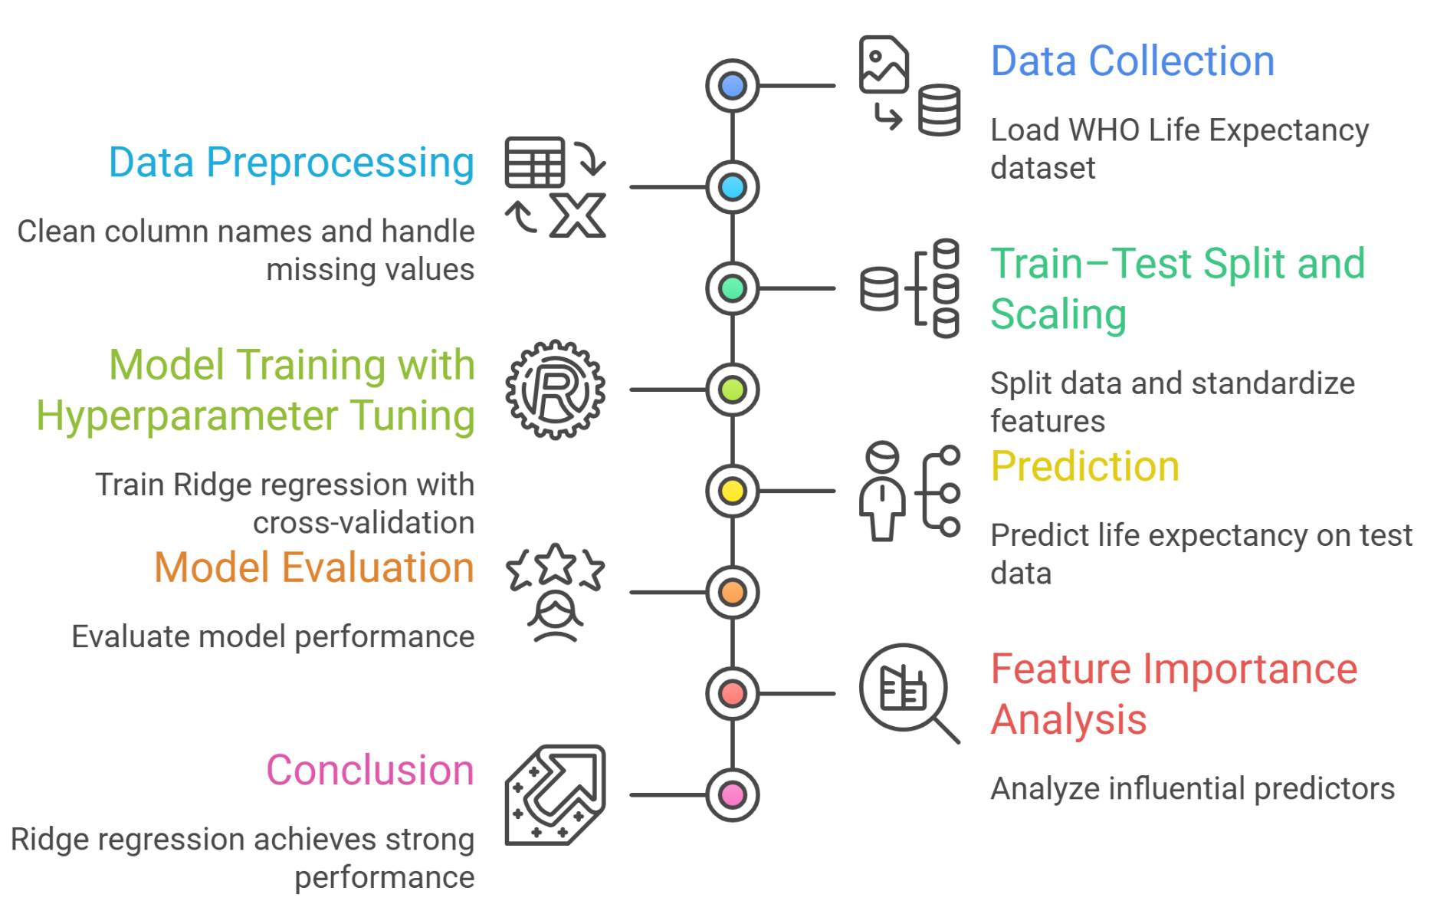
- Data Collection: The netflix_titles.csv dataset is loaded into a Pandas DataFrame containing movie and TV show information.
- Data Preprocessing:
• Missing values are handled appropriately
• Categorical features (type, rating, country) are encoded into numerical format using Label Encoding
• Relevant features are selected for classification
- Train–Test Split and Scaling: The data is split into 80% training and 20% testing sets. All features are standardized using StandardScaler, which is required for Ridge regression.

- Model Training and Prediction: Ridge regression with cross-validation (RidgeCV) is trained to automatically select the optimal regularization hyperparameter (alpha). The trained model is then used to predict life expectancy on the test data.
- Model Evaluation and Interpretation: Performance is evaluated using RMSE and R² score. Ridge coefficients are analyzed to identify important predictors, noting that coefficients are shrunk but not reduced to zero.
- Conclusion: Ridge regression achieves strong predictive performance (R² = 0.82, RMSE ≈ 3.9 years) while effectively handling multicollinearity among features..

Performance Analysis:
The performance of the implemented Ridge Regression model is evaluated using Root Mean Squared Error (RMSE) and the R² score, which measure prediction accuracy and explanatory power.
- RMSE Analysis: The model achieved an RMSE of approximately 3.9 years, indicating that the predicted life expectancy values differ from the actual values by about 3.9 years on average. This low error suggests that the model provides accurate predictions despite the inherent variability in public health data.
- R² Score Analysis: An R² score of 0.82 indicates that Ridge regression explains 82% of the variance in life expectancy. This demonstrates a strong linear relationship between the predictors and the target variable and confirms effective learning from the dataset.

Hyperparameter Tuning:
Hyperparameter tuning was performed to optimize the Ridge Regression model and improve its generalization performance. Instead of using default parameters, RidgeCV was employed to automatically select the optimal regularization strength through k-fold cross-validation. This approach ensures a balance between model complexity and prediction accuracy while reducing overfitting.
Hyperparameter Tuned: Alpha (α) – Regularization Strength:
Alpha controls the magnitude of the L2 penalty applied to regression coefficients.
  - Smaller α values: Weaker regularization, allowing coefficients to remain closer to their original values.
  - Larger α values: Stronger regularization, shrinking coefficients more aggressively to handle multicollinearity.
A logarithmic range of 50 alpha values between 0.01 and 100 was evaluated using 5-fold cross-validation to identify the optimal value.
Optimal Hyperparameter Value:
Best Alpha (α): 0.01
This value indicates that moderate regularization is sufficient to stabilize coefficient estimates while preserving all predictive features.

Code & Output:
import pandas as pd
import numpy as np
import matplotlib.pyplot as plt
import seaborn as sns

from sklearn.model_selection import train_test_split
from sklearn.linear_model import RidgeCV
from sklearn.preprocessing import StandardScaler
from sklearn.metrics import mean_squared_error, r2_score

# =============================
# LOAD NETFLIX DATASET
# =============================
df = pd.read_csv("netflix_titles.csv")

df.columns = df.columns.str.strip()

# =============================
# DATA CLEANING (Netflix Version)
# =============================

# Keep only Movies for regression
df = df[df['type'] == 'Movie'].copy()

# Convert duration text → numeric
df['duration_minutes'] = df['duration'].str.extract(r'(\d+)').astype(float)

# Drop identifier-like columns (same idea as Country/Year)
df = df.drop(['show_id','title','director','cast','date_added','description','duration'], axis=1)

# Handle Missing Values (same style)
df.fillna(df.mode().iloc[0], inplace=True)

# One-Hot Encoding (similar to Status encoding)
df = pd.get_dummies(df, columns=['type','rating','country','listed_in'], drop_first=True)

# =============================
# DEFINE FEATURES + TARGET
# =============================
X = df.drop('duration_minutes', axis=1)
y = df['duration_minutes']

X_train, X_test, y_train, y_test = train_test_split(
X, y, test_size=0.2, random_state=42
)

# =============================
# STANDARDIZATION
# =============================
scaler = StandardScaler()

X_train_scaled = scaler.fit_transform(X_train)
X_test_scaled = scaler.transform(X_test)

# =============================
# RIDGE REGRESSION
# =============================
alphas_to_test = np.logspace(-2, 2, 50)

ridge_cv = RidgeCV(alphas=alphas_to_test, cv=5)
ridge_cv.fit(X_train_scaled, y_train)

print(f"Optimal Alpha (Hyperparameter) found: {ridge_cv.alpha_:.5f}")

y_pred = ridge_cv.predict(X_test_scaled)

# =============================
# MODEL EVALUATION
# =============================
rmse = np.sqrt(mean_squared_error(y_test, y_pred))
r2 = r2_score(y_test, y_pred)

print(f"Ridge RMSE: {rmse:.2f} minutes")
print(f"Ridge R² Score: {r2:.2f}")
# =============================
# CLEAN VISUALIZATION (UPDATED)
# =============================
plt.figure(figsize=(14,6))

coefs = pd.Series(ridge_cv.coef_, index=X.columns)

# 🔥 Show ONLY top 20 important features (cleaner graph)
top_features = coefs.abs().sort_values(ascending=False).head(20).index
coefs_sorted = coefs.loc[top_features].sort_values()

# ---------- Plot 1: Feature Importance ----------
plt.subplot(1,2,1)

coefs_sorted.plot(
kind='barh',
color=(coefs_sorted > 0).map({True:'#4C72B0', False:'#DD8452'}),
edgecolor='black'
)

plt.title("Ridge Feature Importance (Top 20 Features)", fontsize=12)
plt.xlabel("Coefficient Value")
plt.ylabel("")
plt.grid(True, axis='x', linestyle='--', alpha=0.4)
plt.tight_layout()

# ---------- Plot 2: Actual vs Predicted ----------
plt.subplot(1,2,2)

plt.scatter(
y_test, y_pred,
alpha=0.6,
s=40,
edgecolors='black'
)

plt.plot(
[y_test.min(), y_test.max()],
[y_test.min(), y_test.max()],
'r--', lw=2
)

plt.xlabel("Actual Duration")
plt.ylabel("Predicted Duration")
plt.title("Actual vs Predicted (Ridge Regression)", fontsize=12)
plt.grid(True, linestyle='--', alpha=0.4)

plt.tight_layout()
plt.savefig('ridge_results_clean.png', dpi=300)
plt.show()
# =============================
# PRINT TOP FEATURES (LIKE ORIGINAL NOTEBOOK)
# =============================
coefs = pd.Series(ridge_cv.coef_, index=X.columns)

print("\nTop 5 Most Important Features (Ridge):")
print(coefs.abs().sort_values(ascending=False).head(5))

